 | 7.1.37 Editors - 3D Viewport - Header - Grease Pencil - Weight Paint Mode - Weights Menu
Table of content
Weight Paint Mode - Weights Menu 1
Normalize All 1
Last Operator Normalize all Vertex Group 1
Lock Active 1
Normalize 2
Invert 2
Clean 2
Adjust last operator Clean Vertex Group Weights. 2
Subset 2
Limit 2
Keep Single 2
Quantize 2
Adjust last operator Quantize Vertex Group 2
Subset 2
Steps 2
Levels 2
Adjust last operator Clean Vertex Group Weights. 3
Subset 3
Offset 3
Gain 3
Smooth 3
Last Operator Smooth Vertex Group 3
Factor 3
Iterations 3
Sample Weight 3

Weight Paint Mode - Weights Menu

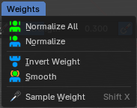

Normalize All
Normalizes the weight of all Vertex groups so that the values for the single vertices in the sum is 1.

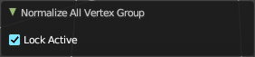
Last Operator Normalize all Vertex Group

Lock Active
Keep the values of the active group while normalizing others.

Normalize
Normalize normalizes the weight of the current selected Vertex group so that the values for the single vertices in the sum is 1. Means when there is influence from other groups, then those values are kept, but the one for the current group gets lowered so that the sum is 1.

Invert
Invert inverts the weight painting for the selected vertex group.

Clean
Remove vertex group assignments which are not required.

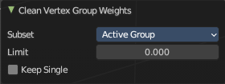
Adjust last operator Clean Vertex Group Weights.

Subset
Which group should be used.

Limit
Add vertices from groups that have zero weight before inverting.

Keep Single
Keep vertices that are assigned to at least one group when cleaning.

Quantize
Set the weights to a fixed number of steps. Going from 0 to 1.

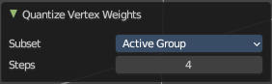
Adjust last operator Quantize Vertex Group

Subset
Which group should be used.

Steps
The number of steps between 0 and 1.

Levels
Add some offset and multiply with some gain the weights of the active vertex group.

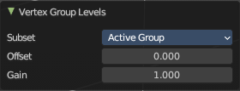
Adjust last operator Clean Vertex Group Weights.

Subset
Which group should be used.

Offset
The offset value to add to the weights.

Gain
Value to multiply weights by.

Smooth
Smooths the weight for selected vertices.

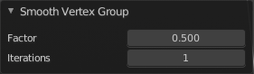
Last Operator Smooth Vertex Group

Factor
Here you adjust the factor.

Iterations
Here you adjust how many iterations you use.

Sample Weight
Pick the weight under the mouse by a click.

